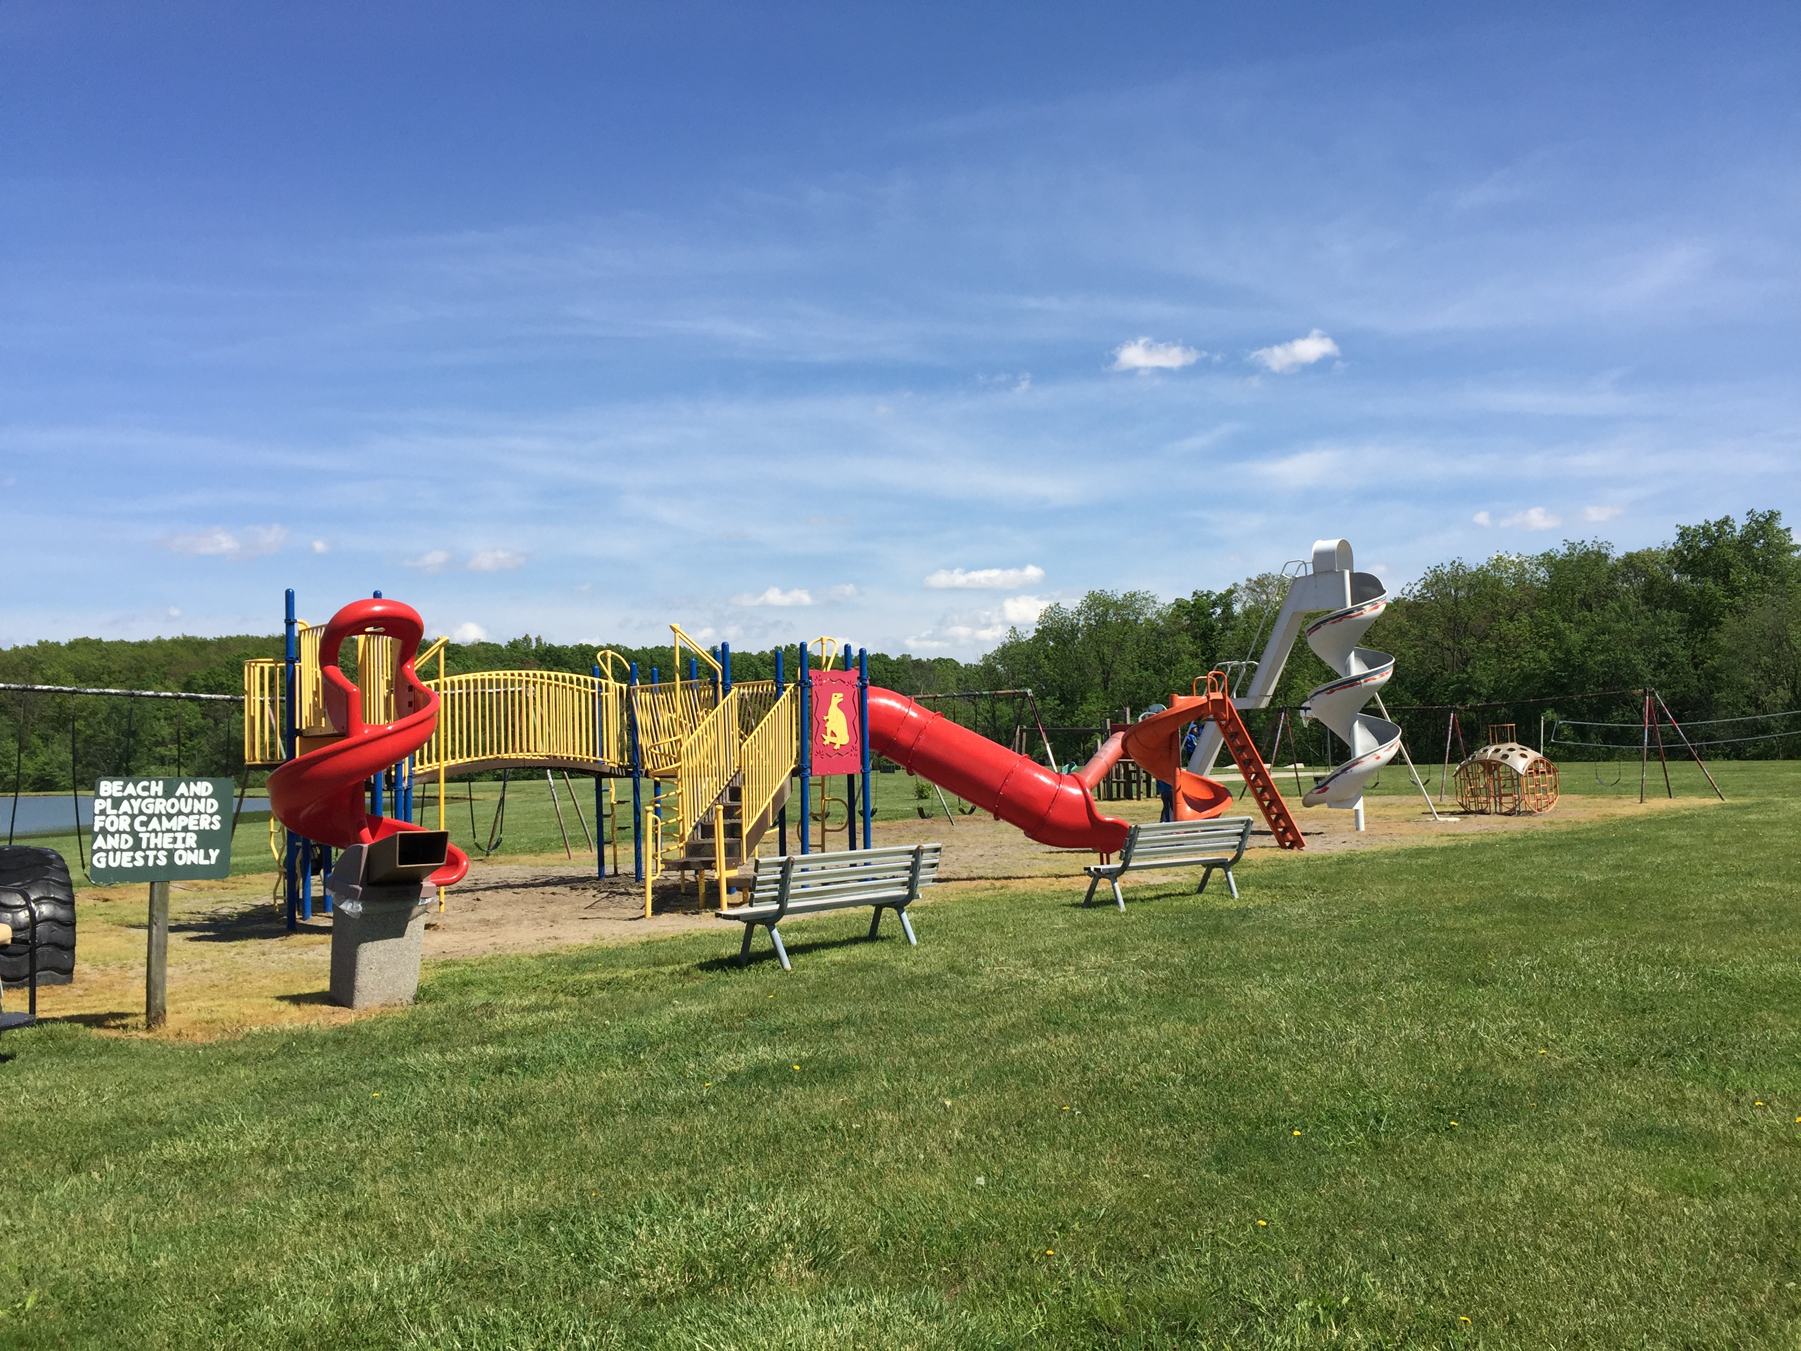
HICKORY ACRES CAMPGROUND SEASONAL CAMPING RULES
(Your signed contract verifies you will abide by these rules.)
1. A deposit of $600 by September 15 will reserve a seasonal site for the following year. (Exceptions are evictions.) If the deposit is not paid by September 15, there will be a $50.00 late fee. Deposits are NONREFUNDABLE.
2. A balance of $1350.00 is due by April 15. Payments are accepted through the winter months. Payments are due in full by April 15. There will be a $250.00 late fee for all payments received after April 15.
3. Electricity is in addition to the seasonal fee and is due monthly.
4. Quiet Time: Weekdays 10 p.m.—8 a.m. Weekends 11 p.m.—8 a.m.
5. All minors must return to their campsite by quiet time, or immediately after activity they are participating in if it’s past quiet time.
6. NO REFUND to campers leaving before the end of the season, or to people asked to leave the campground. Sellers: if you to sell your camper with the lot the following rules apply effective August 25, 2019:
*the rent follows the camper, so the buyers do not owe any rent for the rest of the season
*the buyers MUST be approved by the Owner
*Sellers will pay 10% of the selling price to the campground for the privilege to sell a camper here, and let it set. The
minimum selling fee is $1000.
*You MUST provide proof of the selling price to the owner. (copy of the check/money order, etc.)
*if you wish to avoid the selling fee, you have the option to remove your camper & sell it on your own property
7. This is a privately owned park and anyone suspected or arrested of illegal/criminal activities could or will be asked to leave the campground immediately. Since this is a privately owned park we reserve the right to prohibit the use of legalized marijuana use.
8. Speed limit is 5 mph in the park. Children dart—Drive Smart!
9. Parents are responsible for the conduct & compliance of rules for their children & guests.
10. Campsites are to be kept clean at all times. (i.e. lawns mowed, trailer washed & clean, weeds trimmed, no trash & no junk). If your site is continuously dirty, you will be asked to leave.
11. Leave the restrooms like you would like to find them.
12. No cutting of trees.
13. No lifeguard on duty at the beach—swim at your own risk. Children must be accompanied by an adult.
14. Day guests must leave by quiet time. Overnight adult guest fee is $5. This includes adult family members.
15. All trash must be placed in plastic bags & deposited in dumpsters. Use dumpsters for trash from here—not brought in from other places. Please do not throw cigarette butts on the ground.
16. Dispose of glass bottles properly in trash.
17. Respect your neighbors. Excessive noise or other nuisances not permitted.
Continues on backside……..

18. Pets must be on a leash, and you must clean up after your pet. Pets becoming a nuisance will be asked to leave. They must be registered at the office. DOGS NOT ALLOWED ON PREMISES: AKITA, CHOW, DOBERMAN, PIT BULL, PRESA CANARIO, ROTTWEILER, STAFFORDSHIRE TERRIER, ALL WOLF HYBRIDS. ANY DOG WITH ANY OF THESE AS A MIXED BREED IS INCLUDED. GERMAN SHEPHERDS MUST HAVE PROOF OF INSURANCE ON HOME OWNER POLICY.
19. Personal golf carts must be operated by an INSURED LICENSED DRIVER (this included teens with moped licenses. The office must have a copy of the photo ID). Proof of Insurance is required before operating it on campground property. Misuse will result in not being permitted to have one at the campground. Golf carts must have a light at night. No riders on the back if there is not a back seat.
20. No other motorized wheeled vehicles (4-wheelers, mini bikes, etc.) are allowed.
21. One camping unit and 1 tent per site. Or 2 tents per site. (State Regulations)
22. No refrigerators outside, unless they are inside a bin or shed.
23. No personal paddle boats or watercraft are to be left at the pond.
24. If we mow your yard it costs $15 each time, or a seasonal rate of $250.
25. Fishing is catch and release only.
26. Be considerate of others yards! Don’t drive through, park on, etc. others yards without permission.
27. No lumber built awnings. (State regulations)
28. Bikes at night should have a light.
29. Sheds are to be no bigger than 10’x 12’ & only one story tall.
30. No one can inherit your lot. Once you are done camping (however that occurs) the lot becomes ours again.
31. No duct tape on pavilion tables.
32. Before building anything, permission from owners is required.
33. No selling of your own personal business products in the campground.
34. If you use the pavilion you MUST clean it, which includes taking out the trash & replacing them with our
bags. If not, a $50 fee will be applied to your bill.

THESE RULES MAY BE ADDED TO, SUBTRACTED FROM, OR CHANGED AS THE OWNERS SEE FIT. Your signed contract includes agreement to abide by any additions, deletions, or changes for the duration of your stay at Hickory Acres Campground.
NOTE TO OUR GUESTS: THIS PROPERTY IS PRIVATELY OWNED & THE OWNERS RESERVE THE
RIGHT TO REFUSE SERVICE TO ANYONE. RESPONSIBILITY: The owners will not be responsible for any of the following:
*Accidents or injuries suffered by the Guest.
*Loss of valuables such as money, jewelry, or any other items that are the personal property of our Guests.
*Any other acts that are beyond the control of the owners.



